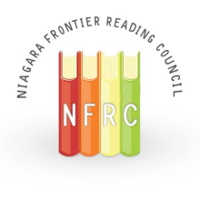
Spotlight
Volume LXIII, No. 2
ILA Honor Council - #35575
February 2021

President’s Message by Heidi J. Clarke
WHY?
Many years ago, when I was a new teacher, a colleague invited me to the NFRC Fall conference. I continued to attend NFRC events and a few years later I was asked to become a board member. Eventually I was nominated for an officer position and served as President for the 2002-2003 academic year. Now, nearly 20 years later, I am honored to again serve as President. I have been reflecting on why I first became involved with the NFRC, and why it has been an important part of my life all these years.
One reason that the NFRC is important to me is, obviously, the professional development opportunities that the organization continually offers. I have learned from many important educational “celebrities” who have traveled either across town or across the country to share their ideas and proven strategies. Even in this exceptional year, the NFRC continues to provide opportunities for PD, in conjunction with other New York State Reading Association councils. However, this is not the only, or even the main reason, that I am a member of the NFRC.
Whenever I attend an NFRC event I leave inspired, but not just by the presenter. I am inspired by the other participants. I meet new people and hear about their classrooms and students. I leave with a fresh outlook and ideas to try on Monday morning. I’ve made friends and professional connections. I have the opportunity to share my thoughts and ideas, and receive feedback from a new perspective. Furthermore, I am inspired by the dedication of the “behind the scenes” workers who organize the event, take registrations, stuff folders, and do the many other jobs to make the event enjoyable for the teachers in attendance. Also, I’ve developed lasting friendships working alongside them.
Another important reason I am a member of the NFRC is the organization’s commitment to promoting literacy locally and around the world. The NFRC outreach programs include providing books and bookshelves to families at Habitat for Humanity home dedications, installing and maintaining Little Free Libraries, and donating school supplies and books to schools in developing countries. I believe we are making a difference when I imagine a child reading a book he has received through one of these programs.
Why am I a member of NFRC? Why should you consider taking a more active role in the Niagara Frontier Reading Council? The reasons are many: professional growth, personal connections, and opportunities to promote literacy locally and internationally. Please invite a friend or colleague to join or attend an event with you, as someone invited me many years ago.
If you would like to take a more active role in the Niagara Frontier Reading Council, please contact me: heidiread@yahoo.com . You will be glad you did!
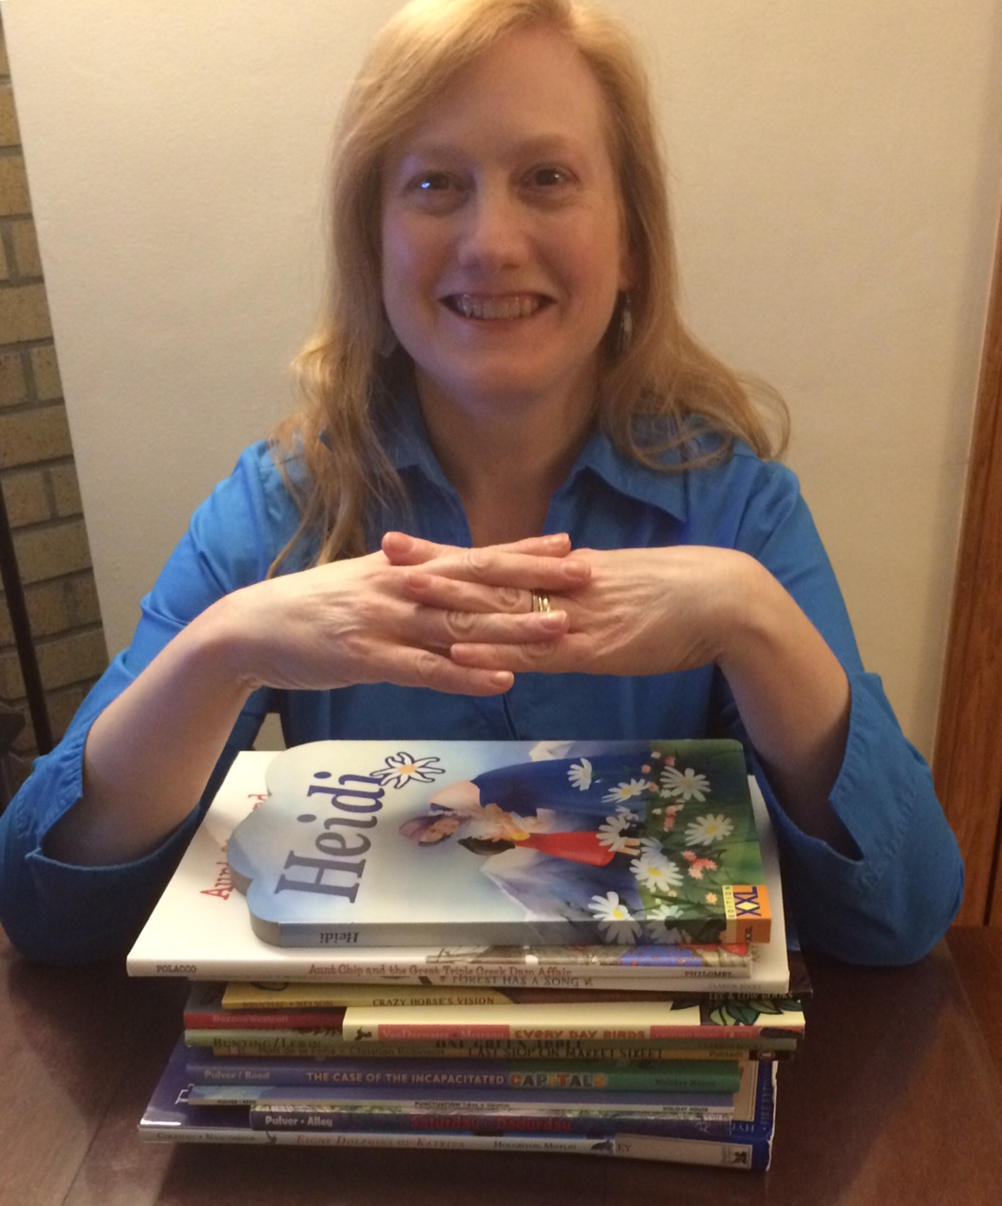

NFRC Professional Book Discussion Group
The NFRC Professional Book Discussion Group is pleased to announce its spring schedule. Please visit the PBDG page on the NFRC website for all the details and to register for the first free virtual event taking place on February 8 from 7:00-8:30pm. CTLE credit will be offered to participants. Friends of the NFRC and parents are welcome to join the discussion of this timely topic.

Also, a free virtual author event is being hosted by Monkey See, Monkey Do. Katherine May, author of the Indies Bestseller, Wintering: The Power of Rest and Retreat in Difficult Times, will be joining in an hour-long conversation about her book on Saturday February 6 at 11am. Register for the event here. Contact Kim Krug to order a copy of the book at a discount.

Questions? Contact Judy Bradbury at judybradburywrites@gmail.com.

Please note! Because of our lack of fundraising ability, please consider a donation to the Outreach Committee of NFRC so we can keep putting great books into the hands of needy students! --Susan Busch
The NFRC Wants You!

If any member would like to take a more active role in the NFRC, please email Heidi Clarke at heidiread@yahoo.com.

Self-Care for Educators

Educational Leadership (Dec 2020/Jan 2021) recently contained an article addressing teachers’ thinking, How Cognitive Distortions Undermine Well-Being, by Chase Mielke. He felt that self-care is important so teachers can do their jobs helping others also struggling with the pandemic. He was concerned about the way one thinks can undermine one’s well-being and can destroy civility. He suggested that in the New Year, one should consider improving thinking. He listed five problematic types of thinking.
- Polarized thinking. Not everything is black and white. But brains under stress seek short cuts to explain things in the attempt to save time. Either that lesson was perfect or I am a failure. Reframing black and white thinking is important, recognizing there can be middle ground. Teaching virtually is not why I became a teacher, but I can still build personal connections and share my passion for my content.
- Emotional reasoning. Emotions that are strong can sway thinking into errant beliefs. I feel bad, so I must be bad. There has to be that recognition that emotional states do pass and change. I’m feeling defeated because that didn’t go as planned. I feel bad, though, because I care. I can try again.
- Mind reading. Sometimes when there is no immediate answer, a guess is made. But an attempt at guessing (mind reading) may tend to settle on the worst-case scenario. Students didn’t do the assignment because they’re lazy. But it is necessary to seek clarity. It is better to ask to get at the true answer rather than ruminate over it alone. I noticed the lessons didn’t seem to work the other day, but I do want them to be helpful. What feedback can you give me?
- Pervasiveness. An idea that seems to recur doesn’t necessarily make it an all encompassing truth. Students say they hate reading and then read their cell phone texts. It’s that students don’t like “boring” reading assignments. Just because a behavior or an idea is observed doesn’t imply it is always the truth. Just because I had a couple students challenge me today doesn’t imply that I can’t figure how to manage this better.
- Permanence. This pandemic will never end. I am always going to be tired. Hyperbole can tear one down. But conditions do change and the always/never statements only drag teachers down. Again, rethinking and challenging such thoughts promotes self-care. This kid has a lot of bad behaviors. But, he’ll get there with extra modeling and support.

The point of the article: take care of yourself by rethinking and having a more positive outlook by recognizing the possibilities. We need to take care of each other in this crisis. But we have to take care of ourselves so that we are able to take care of others.
Jack Agugliaro

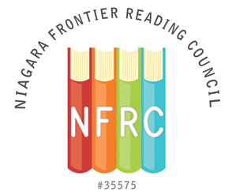
Niagara Frontier Reading Council
An ILA Honor Council - # 35575
Annual Membership Application (9/1/2020 – 8/31/2021)

Join/Renew Today!
NFRC membership has great privileges: includes membership to the New York State Reading Association (NYSRA), NFRC member events, access to NYSRA’s member events, digital publications from NFRC and NYSRA, PD/CTLE credits, Professional Book discussion Group, awards, local/international community outreach, and more!
Register online: www.theNFRC.org or mail completed form below.
Payment can be made via PayPal, check/money order (U.S. funds only) to “NFRC.”
Mail to: Carol Bush, 57 Minard St., Lockport, NY 14094

Last Name___________________________________________ First Name_________________
Street Address__________________________________________________________________
City_________________________________________________ State_____ Zip Code________
Phone_______________ E-Mail Address_____________________________________________
Position____________________________ Level (Elem., Secondary, Post-Sec.)______________
School/District/University_________________________________________________________
Are you a current member of the International Literacy Association (ILA)?
___Yes/Member #______________ ___No
Are you interested in hearing about leadership opportunities in the NFRC? ___Yes ___No
Member Category
Professional - $35
Student (*must be full-time student and submit current I.D with form) - $15

Total Amount Due $__________
An ILA Honor Council

Full-Time Student Member Verification

Full-Time College Student’s Name______________________________________
Degree Program: ____________________________________________________
College/University: __________________________________________________

***I acknowledge that the student named above is a full-time college student at the college or university where I teach.

Instructor Signature: _________________________________________________
Instructor’s Title: ____________________________________________________
Date: __________________________________

Please Note: In addition to this signed letter, the full-time college student must include a copy of his/her current and valid college identification card to be eligible for the student membership rate.

NFRC Officers for 2019-2020:
President – Heidi Clarke
Past President – Kirsten Burke Smith
President Elect – Gina Niemel
Vice President for Programming – Dr. Ashlee Campbell
Programming Advisor – Patty Oliphant
Treasurer – Susan Busch
Recording Secretary - Jack Agugliaro
Director of Membership - Carol Bush
Corresponding Secretary –Jack Agugliaro
Board Members 2018-2020 Term:
Judy Bradbury
Lindsey Buck
Pamela Garabedian
Patricia Oliphant
Board Members 2019 - 2021
Elizabeth Bystrak
Dr. Tiffany Karalis-Boyd
Michele Montoro
Mary Beth Scumaci
Dr. John Strong
2020-2021 Committee Chairpersons
Council Awards Chair - Lindsey Buck
CTLE Chair/ Mini Grants Chair - Patricia Oliphant
Fall Event Chair/ CTLE Professional Development Chair - Judy Bradbury
Finance / Budget Chair - (VACANT)
History Chair- Pamela Garabedian
Nominating Chair - (VACANT)
Outreach Chair - Susan Busch
Spotlight Editor - Jack Agugliaro
Social Media Network – Heidi Clarke
Web Co-Designer & Editor - Mary Beth Scumaci
Liaison Chair - Jack Agugliaro
Audit Chair – Betsy Marshall
Western Regional Director 2018-21, NYSRA - Cherie Gerych

About the NFRC:
• We are non-profit educational organization chartered by The International Literacy Association since 1958.
• We are dedicated to the professional development and enhancement of literacy in our community.
• We are involved in professional issues affecting literacy.
NFRC Mission:
Our mission is to promote literacy education, encourage professional development, and provide community service, which fosters literacy within Western New York. We hope to instill a passion for lifelong learning and encourage readers to build a vision of the future.

Upcoming Events
*October 24, 2020 – 9 a.m.-11 a.m. Professional Book Discussion Group
*November 13, 2020 – 7:30 p.m. NYSRA Webinar with Cornelius Minor
*November 21 from 9am-11am NFRC Zoom meeting to discuss Minor’s presentation
*February 8, 2021 - 7pm Professional Book Discussion Group

