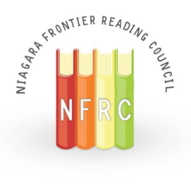
Spotlight
Volume LXIV, No. 2
ILA Honor Council - #35575
December 2021

Co-Presidents’ Messages

Co-President's Message- December 2021
The Holiday season and the coming New Year is a time for reflecting on the past and looking ahead to the future. This December, I am thinking about past NFRC events and working with the Board members to plan programs and events for 2022. Over the past 20+ years that I have been an NFRC member, I have attended Winter and Spring brunches at a variety of area restaurants and banquet halls. We listened to and learned from local and national leaders in literacy instruction. I also recall many NFRC Fall Conferences held at different public schools across Western New York. I loved attending sessions led by local teachers who shared the innovative ways they helped students grow as readers and writers. These events were well-attended by educators from many different schools. At all of these events I looked forward to meeting new people and reconnecting with colleagues.
Sadly, over the past several years, attendance at these events has dwindled. My hope for the New Year is that the Niagara Frontier Reading Council will experience a revival. This depends on input from our members:
  - What programs or events would you like to attend?
  - Is there a topic or speaker that you would like featured?
  - The NFRC is committed to community service as well as professional development. Do you have an idea for promoting literacy in the home or community?
In addition, we are seeking individuals to fill seats on our Board. Please consider taking an active role in your professional organization.
Do you remember the Buffalo Bills’ win over the Houston Oilers in January 1993? That game still holds the record for the greatest comeback in NFL history. Do you also remember the past NFRC brunches and conferences? With your help, the NFRC can also make a great comeback!
Please contact me at heidiread@yahoo.com with ideas for professional development topics, community events to promote literacy, or if you would like to become a Board member. I welcome all ideas and suggestions.
I wish you health and happiness in 2022,
Heidi Clarke
Co-President
*****
Co-President’s December Message
December can be one of the busiest months of the year, but I hope you will take a few minutes to look through this Spotlight to learn about our upcoming events and our 2022 awards options. We, at NFRC, are looking forward to offering a few virtual and in-person literacy events in the New Year.

January:
NFRC board members made the decision to postpone our Fall SEL event until January. And, to better reflect the content of the event- an event geared towards helping children- the presenter revised the title a little bit. The January SEL event, “Using the Nervous System to Manage Student Behavior,” will consist of four sessions (3 virtual and 1 virtual or in-person) to provide educators with background knowledge and 50 strategies that can be used to help students be in a ready-to-learn state. Members and non-members can register for this event. If you know an educator who would be interested in this event, please pass along the information & flyer below. 5 CTLE credits are available!

February:
The Professional Book Discussion Group will be holding a meeting in February to discuss a book related to our January SEL event. Don’t worry- if you couldn’t attend the January event, you can still attend the book discussion group. This event is for members only. Specific information and the registration link is below. 2 CTLE credits are available.

Spring 2022:
Please continue to check the NFRC website for updates on spring events. We hope to add two more events.

Sincerely,
Ashlee Campbell
Co-President, Niagara Frontier Reading Council 2021-2022

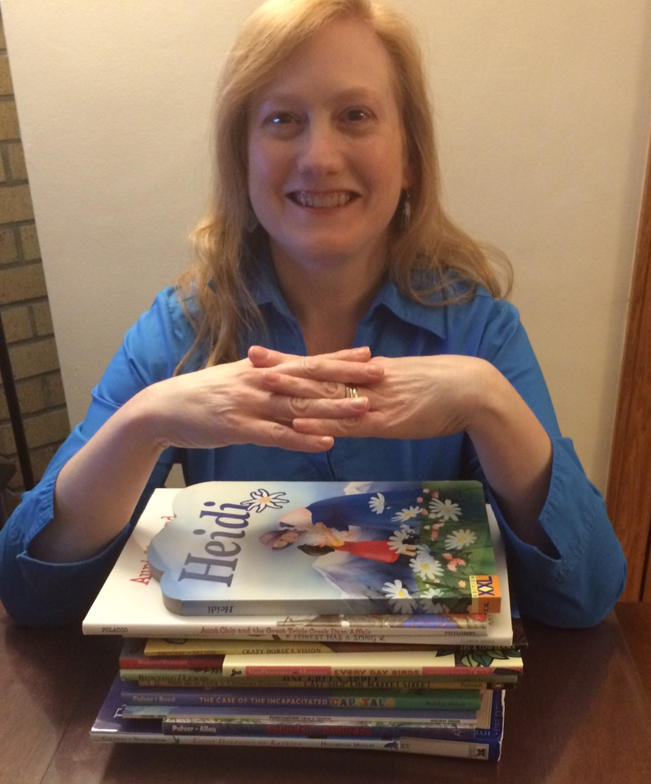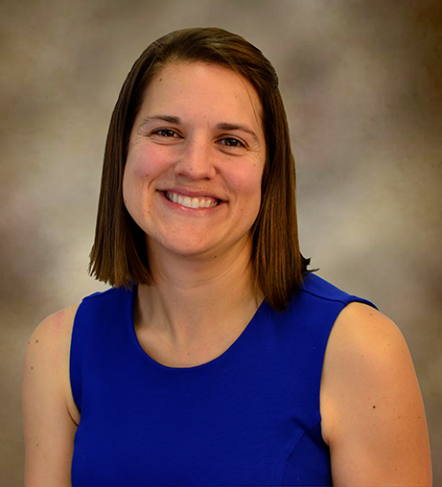
Heidi Clarke Ashlee Campbell

Spring 2022 NFRC Programming
Using the Nervous System to Manage Student Behaviors

Our originally planned October event on social-emotional learning (SEL) has been rescheduled for January 2022. We know that social-emotional health is linked to academic health. Let’s help support our students’ academic health by also supporting their social and emotional needs. This presentation is designed to help all educators better support their students.

Dates/Times
- The first three sessions will be virtual and will be held on three consecutive Wednesdays: January 5, 12, and 19, 2022, from 6:30-7:30pm. (These sessions will be recorded so that if you need to miss one session you can catch up at home during the week).
- The fourth session will be a two-hour, in-person or virtual session on Saturday, January 22nd from 1-3 p.m. This session will allow participants to learn about classroom activities and interventions that support SEL. Participants will leave with activities that can be used immediately in the classroom to support SEL.

Presenter Info

Lauren Etu, a 20+ year school psychologist, will present “Using the Nervous System to Manage Student Behaviors.” Feedback from Lauren’s previous presentations has been very positive. She is an excellent speaker and understands the need for educators to have a toolbox of useable school-based strategies.

CTLE Credits:

5-CTLE credits are available for participants that attend all 4 sessions.

Cost
- $40 for NFRC member
- $60 for non-members.

Registration is required. Participants must register for the entire event. Register here.
This event is brought to you in collaboration with the Monkey See, Monkey Do Bookstore & UB’s Center for Literacy and Reading Instruction (CLaRI). Contact Ashlee Campbell with questions (ashleeeb@buffalo.edu).

Professional Book Discussion Group Continues Study of SEL
The NFRC Professional Book Discussion Group will meet via Zoom on Wednesday, February 9th from 6:30-8:30pm to discuss Chapters 1-4 in All Learning Is Social and Emotional: Helping Students Develop Essential Skills for the Classroom and Beyond by Nancy Frey, Douglas Fisher, and Dominique Smith.
The meeting is open to all NFRC and NYSRA chapter members. NFRC board member Jack Agugliaro will lead the discussion. Two CTLE credits will be available to all participants.
All Learning Is Social and Emotional: Helping Students Develop Essential Skills for the Classroom and Beyond is available through local bookseller Kim Krug at Monkeys Read (books@monkeysread.com or 716-204-8417). Kim is offering NFRC members a generous educator discount and free delivery within 25 miles of Clarence, NY. The book is also available through other booksellers and online.
Pre-registration for the meeting is required; please register here (https://docs.google.com/forms/d/e/1FAIpQLSetmqic0PNZnrkVFklsUIwnS4FKojp3BYip0TNfoVf0YC2ZNA/viewform) by Sunday, 2/6 to receive the link to join the meeting.
Questions? Contact Judy Bradbury at judybradburywrites@gmail.com.
The NFRC Wants You!
If any member would like to take a more active role in the NFRC, please email Heidi Clarke at heidiread@yahoo.com.

NFRC Local Awards
Every year the Niagara Frontier Reading Council presents two prestigious local awards, the Service to Reading Award and the Certificate of Appreciation Award.
We would love to hear who you think deserves the awards.

Nominations are due March 20th
​
The Service to Reading Award | Certificate of Recognition
- Will be given to a person, involved in literacy education, who has made a significant contribution promoting literacy in the community.  - The recipient should be a member of the Niagara Frontier Reading Council. |  | - Will be awarded to a person or a group not affiliated with the Niagara Frontier Reading Council and not a paid, professional educator.  - The Certificate of Recognition is for service to, or promotion of, the council’s goals.
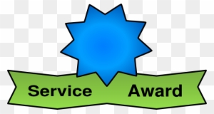

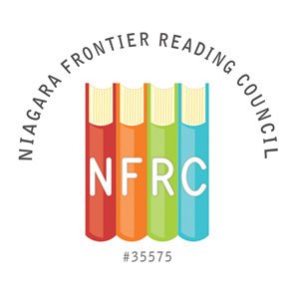
NFRC SERVICE TO READING AWARD NOMINATION FORM

The Service to Reading Award will be given to a person, involved in literacy education, who has made a significant contribution to promoting literacy in the community. The recipient should be a member of the Niagara Frontier Reading Council.

The deadline for nomination submission is March 20, 2022

Submit completed form to: Niagara Frontier Reading Council @ thenfrc@gmail.com
Please state “NFRC Awards” in the subject line

Person Submitting Nomination

Name: ________________________________________________________________________
Address:______________________________________________________________________

________________________________________________________________________

Phone:_______________________Email:____________________________________________

Nominee Information

Name: ________________________________________________________________________
Address:______________________________________________________________________

_______________________________________________________________________

Phone:_______________________Email:____________________________________________

Institutional Affiliation:__________________________________________________________

Position:_____________________________________________________________________
Please provide a description of the nominee’s contribution to promoting literacy in the community (please limit description to one page, single, spaced, 12pt font).
NFRC CERTIFICATE of RECOGNITION AWARD NOMINATION FORM

A Certificate of Recognition will be given to a person or a group not affiliated with the Niagara Frontier Reading Council and not a paid, professional educator. The Certificate of Recognition is for service to, or promotion of, the council’s purposes.

The deadline for nomination submission is March 20, 2022

Submit completed form to: Niagara Frontier Reading Council @ thenfrc@gmail.com
Please state “NFRC Awards” in the subject line

Person Submitting Nomination

Name: ________________________________________________________________________
Address:______________________________________________________________________

_______________________________________________________________________

Phone: _______________________Email:___________________________________________

Nominee Information

Name: ________________________________________________________________________
Address:______________________________________________________________________

_______________________________________________________________________

Phone: _______________________Email:___________________________________________

Institutional Affiliation:__________________________________________________________

Position:______________________________________________________________________
*Repeat the above information for each person if a group is being nominated
**Please provide a description of the nominee’s contribution to promoting literacy in the community (please limit description to one page, single, spaced, 12pt font).
Article Review: 6 Intrinsic Motivators to Power Up Your Teaching

So, what motivates you? What makes you do what you do? Mike Anderson, a teacher, author, and educational consultant, and writer of the article included in Educational Leadership (Dec. 2021/January 2022), is a runner! He is motivated by music, his plans to run a half-marathon and friends he plans to run with. I began to think about what motivates me to run. I actually like it. I like the fresh air. When I am in a theatrical play, I rehearse my lines while I run. So, I had self-reflected, as I am sure Anderson wanted me to do.
I believe he has corralled those items on which teachers need to focus. Each can be utilized throughout the educational day and year, and certainly in literacy.

Autonomy – Students are more likely to learn and be excited about learning if they have some power and control over how they learn. If studying a particular genre of literature, choice can become on motivating factor. Other ideas here can be choices of where to work and ways to show learning has occurred.

Belonging – Students like a sense of belonging and connection with others. Collaborative learning can be used. One idea that occurred to me is having two or three students choose to read the same book, discuss it and then present in some way to show what they’ve learned.

Competence – Challenges that are within students’ reach motivate them to learn. This is where differentiation is very important. Teachers’ awareness of student reading levels is necessary to keep pupils in a zone of motivation. Teachers need to avoid learning that is too hard, causing frustration, and learning that is too easy, opening the door to boredom.

Purpose – Students will ask the reason for that which they are learning. The need a purpose in the moment, not something they will need in years to come, a more adult goal. Projects or other educational products can be published and used by others, certainly a clear purpose.

Fun – Not all schoolwork is fun, but much of it can be and that increases motivation. A reading skills game I used for years was tic tac toe. Nine categories, which were changed daily, on a bulletin board and later on a Smart Board, were to be addressed by two student players at a time. My aides and I created the questions based on information from a management system used in the reading program. The kids looked forward to playing and it did not seem like work.

Curiosity – Students bring to school their individual interests. Focusing on books that reflect student interests may encourage them to approach assignments with more motivated thinking.

Important note: External motivators often neutralize the intrinsic ones. Incentives like stickers, pizza and others take the focus away from the learning.—Jack Agugliaro
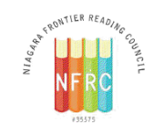
NFRC 2021-2022 Officers & Board Members

NFRC Officers 2021-2022
- Co-President - Heidi Clarke
- Co-President for Programming - Dr. Ashlee Campbell
- Secretary - Jack Agugliaro
- Treasurer - Dr. John Strong
- Director of Membership - Carol Bush

Board Members 2020 - 2022
- Judy Bradbury
- Pamela Garabedian
- Patty Oliphant
- Lindsey Buck

Board Members 2021 - 2023
- Elizabeth Bystrak
- Dr. Tiffany Karalis-Noel
- Christine Woodcock
- Mary Beth Scumaci
Chairperson Positions
Editor of Spotlight- Jack Agugliaro
Web Designer & Editor- Mary Beth Scumaci
Social Media Chair- Dr. Tiffany Karalis-Noel & Dr. Christiana Kfouri
Council Awards Chair- Elizabeth Bystrak
Professional Development Chair- Judy Bradbury
Outreach Chair- Pamela Garabedian; Co-Chair: Judy Bradbury to oversee Little Free Libraries project
CTLE Chair/ Mini Grants Chair-Patricia Oliphant
Finance / Budget Chair-
Nominating Chair - Comprised of the Board
Liaison Chair- Jack Agugliaro
Audit Chair -
Western Regional Director 2018-21, NYSRA - Cherie Gerych

About the NFRC:
• We are non-profit educational organization chartered by The International Literacy Association since 1958.
• We are dedicated to the professional development and enhancement of literacy in our community.
• We are involved in professional issues affecting literacy.

NFRC Mission:
Our mission is to promote literacy education, encourage professional development, and provide community service, which fosters literacy within Western New York. We hope to instill a passion for lifelong learning and encourage readers to build a vision of the future.
*****

Upcoming Events

*SEL event – 3virtual Wednesday sessions January 5, 12, 19, 2022 - 6:30-7:30 p.m.
- in-person event January 22, 1-3 p.m. at UB Reading Center – ClaRI

*Professional Book Discussion Group – February 9, 2022, 6:30 – 8:30 p.m. by Zoom. (Registration information earlier in this issue.)

